Coverpages
VIVEKANAND EDUCATION SOCIETY’S INSTITUTE OF TECHNOLOGY
(An Autonomous Institute Affiliated to University of Mumbai
Department of Computer Engineering)

Department of Computer Engineering


Project Report on
MailedIt: Your Effortless Email Marketing Companion

In partial fulfillment of the Fourth Year (Semester–VII), Bachelor of Engineering
(B.E.) Degree in Computer Engineering at the University of Mumbai Academic Year 2025-26

Prof. Mrs. Geocey Shejy

Submitted by

Priya Anandani - D17A/05
Rishi Daryani - D17A/18
Om Goplani - D17B/68

(2025-26)
VIVEKANAND EDUCATION SOCIETY’S INSTITUTE OF TECHNOLOGY
(An Autonomous Institute Affiliated to University of Mumbai
Department of Computer Engineering)

Department of Computer Engineering


CERTIFICATE of Approval

This is to certify that Priya Anandani, Rishi Daryani and Om Goplani of Fourth Year Computer Engineering studying under the University of Mumbai has satisfactorily presented the project on “MailedIt: Your Effortless Email Marketing Companion” as a part of the coursework of PROJECT-I for Semester-VII under the guidance of Mrs. Geocey Shejy. in the year 2025-2026.
_____________________
Date

__________________ |  | __________________
Internal Examiner |  | External Examiner

_________________ __________________ __________________
Project Mentor Head of the Department Principal
Dr. Mrs. Nupur Giri Dr. J. M. Nair

ACKNOWLEDGEMENT

We are thankful to our college Vivekanand Education Society’s Institute of Technology for considering our project and extending help at all stages needed during our work of collecting information regarding the project.

It gives us immense pleasure to express our deep and sincere gratitude to Assistant Professor Mrs. Geocey Shejy (Project Guide) for her kind help and valuable advice during the development of project synopsis and for her guidance and suggestions.

We are deeply indebted to Head of the Computer Department Dr.(Mrs.) Nupur Giri and our Principal Dr. (Mrs.) J.M. Nair , for giving us this valuable opportunity to do this project.

We express our hearty thanks to them for their assistance without which it would have been difficult to finish this project synopsis and project review successfully.

We convey our deep sense of gratitude to all teaching and non-teaching staff for their constant encouragement, support and selfless help throughout the project work. It is a great pleasure to acknowledge the help and suggestion, which we received from the Department of Computer Engineering.

We wish to express our profound thanks to all those who helped us in gathering information about the project. Our families too have provided moral support and encouragement several times.

Computer Engineering Department

COURSE OUTCOMES FOR B.E PROJECT

Learners will be to:-

Course Outcome | Description of the Course Outcome
CO 1 | Do literature survey/industrial visit and identify the problem of the selected project topic.
CO2 | Apply basic engineering fundamental in the domain of practical applications FORproblem identification, formulation and solution
CO 3 | Attempt & Design a problem solution in a right approach to complex problems
CO 4 | Cultivate the habit of working in a team
CO 5 | Correlate the theoretical and experimental/simulations results and draw the proper inferences
CO 6 | Demonstrate the knowledge, skills and attitudes of a professional engineer & Prepare report as per the standard guidelines.

Abstract

This project focuses on the development of a full-stack email marketing platform, MailedIt, inspired by Mailchimp. The system is designed to provide a comprehensive solution for marketers to manage their email campaigns and audience. The backend, built with Laravel, handles core services such as authentication, user management, subscriber segmentation, and a robust email sending engine. The frontend, developed using React, provides a modern and intuitive web interface, including a campaign creation wizard, a template editor, and an analytics dashboard. By combining these technologies, MailedIt offers a scalable, intelligent, and user-friendly platform for managing all aspects of email marketing operations, from content creation to performance tracking.

Index
INDEX
Chapter No. | Title | Page No.
1 | Introduction
 | 1.1. Introduction to the project | 1
 | 1.2. Motivation for the project | 1
 | 1.3. Drawback of the existing system | 2
 | 1.4. Problem Definition | 2
 | 1.5. Relevance of the Project | 3
 | 1.6. Methodology used | 3
2 | Literature Survey
 | 2.1. Research Papers | 4
 | 2.2. Books / Articles / Newspapers referred | 6
 | 2.3. Interaction with domain experts. | 6
 | 2.4. Patent search you need for study 3-4 patents related to your project | 7
3 | Requirement Of Proposed System
 | 3.1 Functional Requirements | 8
 | 3.2. Non-Functional Requirements | 9
 | 3.3. Constraints | 9
 | 3.4. Hardware & Software Requirements | 9
 | 3.5. Techniques utilized till date for the proposed system | 10
 | 3.6. Tools utilized till date for the proposed system | 10
 | 3.7. Project Proposal | 11
4 | Proposed Design
 | 4.1. Block diagram representation of the proposed system | 12
 | 4.2. Modular diagram representation of the proposed system | 13
 | 4.3. Data Flow Diagram | 14
 | 4.4. Flow Chart of the proposed system | 15
 | 4.5. Screen shots of implementation | 16
 | 4.6. Project Scheduling & Tracking using Gantt Chart | 19
5 | Proposed Results and Discussions
 | 5.1. Determination of efficiency | 20
 | 5.2. Determination of accuracy | 20
 | 5.3. Reports on sensitivity analysis | 21
 | 5.4. Graphs of : Accuracy Vs time | 21
6 | Plan Of Action For the Next Semester
 | 6.1.Work done till date | 22
 | 6.2. Plan of action for project II | 23
7 | Conclusion | 24
8 | References | 25
9 | Appendix
 | 9.1. List Of Abbreviations | 27
 | 9.2. List Of Figures | 28

Report
VIVEKANAND EDUCATION SOCIETY’S INSTITUTE OF TECHNOLOGY
(An Autonomous Institute Affiliated to University of Mumbai
Department of Computer Engineering)

Department of Computer Engineering


Project Report on
MailedIt: Your Effortless Email Marketing Companion

In partial fulfillment of the Fourth Year (Semester–VII), Bachelor of Engineering
(B.E.) Degree in Computer Engineering at the University of Mumbai Academic Year 2025-26

Prof. Mrs. Geocey Shejy

Submitted by

Priya Anandani - D17A/05
Rishi Daryani - D17A/18
Om Goplani - D17B/68

(2025-26)
VIVEKANAND EDUCATION SOCIETY’S INSTITUTE OF TECHNOLOGY
(An Autonomous Institute Affiliated to University of Mumbai
Department of Computer Engineering)

Department of Computer Engineering


CERTIFICATE of Approval

This is to certify that Priya Anandani, Rishi Daryani and Om Goplani of Fourth Year Computer Engineering studying under the University of Mumbai has satisfactorily presented the project on “MailedIt: Your Effortless Email Marketing Companion” as a part of the coursework of PROJECT-I for Semester-VII under the guidance of Mrs. Geocey Shejy. in the year 2025-2026.
_____________________
Date

__________________ |  | __________________
Internal Examiner |  | External Examiner

_________________ __________________ __________________
Project Mentor Head of the Department Principal
Dr. Mrs. Nupur Giri Dr. J. M. Nair

ACKNOWLEDGEMENT

We are thankful to our college Vivekanand Education Society’s Institute of Technology for considering our project and extending help at all stages needed during our work of collecting information regarding the project.

It gives us immense pleasure to express our deep and sincere gratitude to Assistant Professor Mrs. Geocey Shejy (Project Guide) for her kind help and valuable advice during the development of project synopsis and for her guidance and suggestions.

We are deeply indebted to Head of the Computer Department Dr.(Mrs.) Nupur Giri and our Principal Dr. (Mrs.) J.M. Nair , for giving us this valuable opportunity to do this project.

We express our hearty thanks to them for their assistance without which it would have been difficult to finish this project synopsis and project review successfully.

We convey our deep sense of gratitude to all teaching and non-teaching staff for their constant encouragement, support and selfless help throughout the project work. It is a great pleasure to acknowledge the help and suggestion, which we received from the Department of Computer Engineering.

We wish to express our profound thanks to all those who helped us in gathering information about the project. Our families too have provided moral support and encouragement several times.

Computer Engineering Department

COURSE OUTCOMES FOR B.E PROJECT

Learners will be to:-

Course Outcome | Description of the Course Outcome
CO 1 | Do literature survey/industrial visit and identify the problem of the selected project topic.
CO2 | Apply basic engineering fundamental in the domain of practical applications FORproblem identification, formulation and solution
CO 3 | Attempt & Design a problem solution in a right approach to complex problems
CO 4 | Cultivate the habit of working in a team
CO 5 | Correlate the theoretical and experimental/simulations results and draw the proper inferences
CO 6 | Demonstrate the knowledge, skills and attitudes of a professional engineer & Prepare report as per the standard guidelines.

Abstract

This project focuses on the development of a full-stack email marketing platform, MailedIt, inspired by Mailchimp. The system is designed to provide a comprehensive solution for marketers to manage their email campaigns and audience. The backend, built with Laravel, handles core services such as authentication, user management, subscriber segmentation, and a robust email sending engine. The frontend, developed using React, provides a modern and intuitive web interface, including a campaign creation wizard, a template editor, and an analytics dashboard. By combining these technologies, MailedIt offers a scalable, intelligent, and user-friendly platform for managing all aspects of email marketing operations, from content creation to performance tracking.

INDEX
Chapter No. | Title | Page No.
1 | Introduction
 | 1.1. Introduction to the project | 1
 | 1.2. Motivation for the project | 1
 | 1.3. Drawback of the existing system | 2
 | 1.4. Problem Definition | 2
 | 1.5. Relevance of the Project | 3
 | 1.6. Methodology used | 3
2 | Literature Survey
 | 2.1. Research Papers | 4
 | 2.2. Books / Articles / Newspapers referred | 6
 | 2.3. Interaction with domain experts. | 6
 | 2.4. Patent search you need for study 3-4 patents related to your project | 7
3 | Requirement Of Proposed System
 | 3.1 Functional Requirements | 8
 | 3.2. Non-Functional Requirements | 9
 | 3.3. Constraints | 9
 | 3.4. Hardware & Software Requirements | 9
 | 3.5. Techniques utilized till date for the proposed system | 10
 | 3.6. Tools utilized till date for the proposed system | 10
 | 3.7. Project Proposal | 11
4 | Proposed Design
 | 4.1. Block diagram representation of the proposed system | 12
 | 4.2. Modular diagram representation of the proposed system | 13
 | 4.3. Data Flow Diagram | 14
 | 4.4. Flow Chart of the proposed system | 15
 | 4.5. Screen shots of implementation | 16
 | 4.6. Project Scheduling & Tracking using Gantt Chart | 19
5 | Proposed Results and Discussions
 | 5.1. Determination of efficiency | 20
 | 5.2. Determination of accuracy | 20
 | 5.3. Reports on sensitivity analysis | 21
 | 5.4. Graphs of : Accuracy Vs time | 21
6 | Plan Of Action For the Next Semester
 | 6.1.Work done till date | 22
 | 6.2. Plan of action for project II | 23
7 | Conclusion | 24
8 | References | 25
9 | Appendix
 | 9.1. List Of Abbreviations | 27
 | 9.2. List Of Figures | 28

Chapter 1 : Introduction
This chapter introduces the project MailedIt – Your Email Marketing Companion. It presents the motivation behind developing the system, highlights the drawbacks of existing solutions, defines the problem statement, and describes the methodology adopted to design and implement the system. It also explains the relevance and importance of the project in today’s digital marketing environment.

1.1 Introduction to the Project
MailedIt is a full-stack email marketing platform designed to simplify the process of creating, managing, and analyzing email campaigns. The system aims to provide businesses and marketers with a modern, intuitive, and efficient solution for managing their marketing communication.
The backend of the system is developed using Laravel, which ensures secure data handling, reliable API services, and seamless integration with third-party email providers. The frontend is designed using ReactJS, focusing on providing a dynamic and user-friendly interface.
The system includes modules for campaign creation, subscriber management, email template design, and analytics visualization. With a decoupled architecture and scalable infrastructure, MailedIt bridges the gap between simplicity and functionality, empowering users to manage all their marketing needs through one integrated platform.

1.2 Motivation for the Project
In today’s competitive digital era, email marketing continues to be one of the most effective tools for customer engagement and retention. However, many small to mid-scale businesses find existing platforms like Mailchimp and Campaign Monitor expensive, complex, or restrictive.
The motivation behind developing MailedIt is to create an open-source, self-hosted, and cost-effective alternative that combines professional features with simplicity. The project also provides an excellent opportunity to explore full-stack development practices, real-time email delivery systems, and API integration — valuable skills for modern web developers.

1.3 Drawbacks of the Existing System
Existing email marketing platforms, while powerful, come with several limitations:
- High subscription cost: Advanced features are often locked behind paid plans.
- Limited customization: Users cannot modify backend functionalities or add custom logic.
- Dependency on closed ecosystems: Businesses are bound by proprietary APIs and interfaces.
- Data privacy concerns: User and customer data are stored on third-party servers.
- Complex interfaces: Many existing tools are overloaded with features, making them difficult for new users to operate.
MailedIt aims to overcome these limitations by providing an open-source, customizable, and user-friendly alternative that can be hosted and managed independently.

1.4 Problem Definition
Email marketing systems need to handle various critical processes such as audience segmentation, campaign scheduling, performance analysis, and delivery optimization. However, most existing solutions fail to provide a balance between ease of use, scalability, and customization.
The problem is to design and develop a full-stack web application that enables users to manage their complete email marketing workflow — from content creation and campaign management to tracking analytics — within a single integrated platform. The system must be secure, scalable, and intuitive enough for marketers of all experience levels.

1.5 Relevance of the Project
The MailedIt project holds high relevance in the field of digital marketing automation. As more businesses shift toward personalized communication, there is a growing demand for systems that provide control, cost efficiency, and transparency.
By developing this project, students gain hands-on experience in:
- Full-stack development (Laravel + React)
- Integration with third-party APIs.
- Implementing background processing (queues and workers)
- Designing responsive and data-driven user interfaces.

1.6 Methodology Used
The development of MailedIt follows a component-based and decoupled architecture, that ensures it remains modular, scalable and easy to maintain. The major steps include:
- Backend Setup (Laravel):
  - Creation of secure APIs for authentication, user management, and email operations.
  - Implementation of queue-based email dispatch for reliability and speed.
  - Integration with third-party email services for real delivery tracking.
- Frontend Development (ReactJS):
  - Building reusable UI components and client-side routing.
  - Incorporation of a campaign creation wizard and email template editor.
  - Visualization of analytics using charting libraries.
- Database and Cloud Integration:
  - Using MySQL for structured data storage.
  - Utilizing Redis for caching and background jobs.
- Testing and Evaluation:
  - Unit and integration testing of modules.
  - Performance testing of email delivery and API response time.

Chapter 2 : Literature Survey
This chapter reviews recent research work (last 4 years) relevant to email marketing systems. For each selected paper, its abstract is summarized and inferences for MailedIt are drawn.

2.1 Research Papers

[1] A Combined Feature Selection Approach for Malicious Email Detection (2025)
Abstract:
This paper addresses two major challenges in malicious email detection — the lack of unified, up-to-date datasets and the limitations of conventional feature selection that rely only on static or body-text features. The authors propose combining multiple feature types, including protocol-level, header, body, static, and dynamic attributes, to enhance robustness and coverage.
Inference Drawn:
The study highlights that hybrid feature extraction significantly improves phishing and spoofing detection accuracy, reinforcing the need for diverse feature integration in systems like MailedIt to identify spam and malicious content effectively.

[2] Dual-Path Phishing Detection: Integrating Transformer-Based NLP with Structural URL Analysis. (2025)
Abstract:
This paper proposes a dual-path model combining transformer-based text understanding (DistilBERT) with structural URL feature extraction (character-level TF-IDF). The integration allows simultaneous semantic and structural analysis of email content and links, achieving higher phishing detection accuracy while maintaining interpretability.
Inference Drawn:
The work demonstrates that blending NLP-based text modeling with URL-level analysis yields superior detection results — a concept MailedIt can adopt to analyze both message content and embedded URLs for advanced threat prevention.

[3] EvoMail: Self-Evolving Cognitive Agents for Adaptive Spam and Phishing Email Defense. (2025)
Abstract:
EvoMail introduces a self-evolving multi-agent framework where red-team agents generate new phishing tactics while blue-team agents adaptively learn from attacks. Using heterogeneous email graphs that combine content, metadata, URLs, and attachments, the model maintains consistent performance against evolving threats.
Inference Drawn:
The adaptive red-blue learning concept provides insights into how AI agents can continuously update spam detection mechanisms — aligning with MailedIt’s long-term goal of intelligent self-improvement and security enhancement.

[4] E-PhishGen: Unlocking Novel Research in Phishing Email Detection. (2025)
Abstract:
This paper critiques existing phishing detectors and reveals that many achieve near-perfect results only on outdated datasets. It introduces a new multilingual dataset, E-PhishLLM, with recent, realistic phishing samples. The authors emphasize the importance of testing models on modern benchmarks to ensure generalization and reliability.
Inference Drawn:
The study highlights the necessity of using updated datasets and real-world scenarios, guiding MailedIt to evaluate its spam-filtering and analytics modules against realistic, diverse email datasets.

[5] Detecting Email Phishing Using Machine Learning Algorithms. (2025)
Abstract:
The authors compare machine-learning models such as Naïve Bayes, Random Forest, SVM, and K-NN on a dataset of 18,650 emails. Random Forest achieves 98.3 % accuracy with high F1 scores, but the paper notes false negatives remain a concern in cleverly disguised phishing cases.
Inference Drawn:
This study provides quantitative insight into model performance, helping MailedIt benchmark its classification accuracy.
[6] Evaluating Spam Filters and Stylometric Detection of AI-Generated Phishing Emails. (2025)
Abstract:
This research evaluates how existing spam filters (Gmail, Outlook, Yahoo Mail) handle AI-generated phishing emails. Using 60 stylometric features, models such as Logistic Regression, SVM, Random Forest, and XGBoost are tested; XGBoost achieves ~96 % accuracy and high AUC. The paper identifies which linguistic traits are most discriminative in detecting AI-crafted messages.
Inference Drawn:
The findings reveal that even advanced filters can be bypassed by AI-generated phishing, highlighting the need for us to include behavioral analysis in its long-term security roadmap.

2.2 Books / Articles / Newspapers Referred
To understand the foundations of email marketing, automation systems, and web technologies, several books, online articles, and industry reports were referred. These sources provided valuable insights into design principles, market trends, and user engagement strategies relevant to MailedIt.
- Kotler, P. and Keller, K. L., Marketing Management, 16th Edition, Pearson Education, 2022.
  - This book explains the fundamentals of marketing communication and digital outreach, which helped in understanding customer engagement through personalized emails.
- Gallo, A., “How to Master the Art of Email Marketing,” Harvard Business Review, Feb. 2023.
  - The article discusses data-driven decision-making and timing optimization in email campaigns, relevant to MailedIt’s analytics and scheduling modules.
- McKinsey & Company, “The Future of Personalization – 2025 Report,” McKinsey Insights, 2024.
  - This report emphasizes AI-driven personalization and segmentation, supporting the intelligent targeting logic in MailedIt.
- TechCrunch, “How AI Tools are Transforming Email Marketing,” TechCrunch News, 2024.
  - Offers an overview of emerging AI tools used for automating campaign generation and content optimization, aligning with MailedIt’s planned automation features.

2.3 Interaction with Domain Experts
To ensure our project aligns with real-world industry standards, insights were gathered from domain experts and faculty members specializing in web development, marketing automation, and software design.
A detailed discussion was held with Mrs. Geocey Shejy (Assistant Professor, Department of Computer Engineering, VESIT), who provided valuable guidance on the architectural design, modular division, and implementation strategy of the system. Her suggestions helped in finalizing the use of Laravel and React frameworks for building a decoupled yet cohesive architecture.
Additionally, informal consultations with professionals working in digital marketing and SaaS development helped the team understand practical aspects of email campaign management, including delivery optimization, API integration, and analytics tracking. These expert insights guided the refinement of the project scope, feature prioritization, and performance evaluation parameters for MailedIt.

2.4 Patents
Below are some relevant patents pertaining to email marketing, campaign management, template generation, and unified contact systems.
Sr. No | Patent Title & Year | Summary | Inference / Relevance to MailedIt
1. | US 2024/0333675 A1 – Email Management System (2024) | This patent describes a system with a unified contact ID — merging multiple contact records into one, enabling seamless automation and marketing workflows. | In MailedIt, you can implement unified contact profiles so that duplicate or fragmented subscriber entries are handled efficiently, improving campaign targeting and reducing redundancy.
2. | US 10984186 B2 – Smart Electronic Mail and Messaging Templates (issued 2021) | The patent discusses automatically generating email templates by extracting textual elements common across multiple emails to form a “base template,” then customizing parts. | This is directly useful in MailedIt’s email template module — you can use similar logic to create base templates and variational parts dynamically.
3. | “Email Marketing Campaign Auditor Systems” (US Application / Patent) | The system is designed to audit email marketing campaigns: verifying deliverability, checking e-mail server behavior, content compliance, etc. | In MailedIt, include an auditing / compliance module for campaigns (e.g. checking SPAM score, header checks, link health) inspired by this patent.

Chapter 3 : Requirements for the Proposed System
This chapter describes the requirements and specifications of the proposed system, MailedIt – Your Email Marketing Companion. It explains the functional and non-functional requirements, system constraints, hardware and software requirements, as well as the techniques, tools, and algorithms used. The final section presents the complete project proposal derived from the requirement analysis.

3.1 Functional Requirements
Functional requirements define what the system is expected to perform. These are the core features of MailedIt that ensure smooth operation and user satisfaction.
- User Authentication and Role Management:
  - Secure login and registration using Laravel Sanctum.
  - Role-based access for Admin, Marketer, and Viewer.
- Subscriber and Audience Management:
  - Add, edit, or import subscribers via CSV.
  - Segment audiences based on location, behavior, or custom tags.
- Campaign Management:
  - Create, schedule, and send email campaigns.
  - Real-time monitoring of sending progress and delivery status.
- Template Builder:
  - Drag-and-drop or rich-text editor for email templates.
  - Save, edit, or reuse templates for future campaigns.
- Analytics and Reporting:
  - Track open rates, click-through rates, and bounce data.
  - Display performance insights via charts and graphs.
- Queue-Based Email Dispatch:
  - Use Laravel queues and Redis for reliable email sending.
  - Retry mechanism for failed email jobs.
- User Dashboard:
  - Centralized dashboard showing campaign statistics and recent activities.

3.2 Non-Functional Requirements
Non-functional requirements ensure that the system is reliable, efficient, and user-friendly.
- Performance:
  - The system must handle large subscriber lists efficiently using queues.
- Scalability:
  - Must support multiple users and campaigns simultaneously.
- Security:
  - Protect user credentials and subscriber data using encryption.
- Usability:
  - The interface should be intuitive and responsive across all devices.
- Availability:
  - Minimum downtime, with APIs designed for 99% uptime.
- Maintainability:
  - Code should be modular, reusable, and well-documented for future updates.
- Compatibility:
  - Compatible with all modern browsers and responsive across screens.

3.3 Constraints
- Email Delivery Limits: Dependent on third-party email APIs like Mailgun or SendGrid.
- Internet Connectivity: Requires stable network for campaign scheduling and delivery.
- Data Privacy: Must comply with anti-spam laws (CAN-SPAM/GDPR).
- Hardware Resources: Limited by system performance for queue processing and analytics.
- Third-Party Service Reliability: Availability of external APIs directly affects system reliability.

3.4 Hardware and Software Requirements
Hardware Requirements
- Processor: Intel Core i5 or higher
- RAM: 8 GB minimum
- Storage: 100 GB HDD / SSD
- Internet Connectivity
Software Requirements
- Operating System: Windows 10 / Linux / macOS
- Backend: Laravel 12, PHP 8.3+, Composer
- Frontend: React.js, Node.js, npm/yarn
- Database: MySQL
- Cache/Queue: Redis
- Web Server: Apache or Nginx

3.5 Techniques Utilized Till Date for the Proposed System
- API-Driven Architecture: RESTful APIs for smooth frontend-backend communication.
- Queue-Based Processing: Use of Laravel queues for background email dispatch.
- Component-Based Frontend: Reusable React components for efficiency.
- Data Visualization: Use of charting libraries for campaign analytics.
- Authentication and Authorization: Laravel Sanctum for secure access.

3.6 Tools Utilized Till Date for the Proposed System

Category | Tools / Technologies
Backend | Laravel 12, Composer
Frontend | React.js, Node.js
Database | MySQL
Styling | Tailwind CSS
API Client | Axios
Queue / Cache | Redis, Laravel Horizon
Version Control | Git & GitHub
IDE | VS Code / PhpStorm
Deployment | Nginx / Apache

3.7 Algorithms Utilized in the Existing Systems
- Email Segmentation Algorithms:
Used to classify users based on demographics or engagement level.
- Spam Detection Algorithms (Naïve Bayes / XGBoost):
Implemented by existing platforms to validate outgoing content.
- Predictive Engagement Models:
Use logistic regression or LSTM to estimate open and click rates.
- A/B Testing Algorithms:
Evaluate subject line or content variations to maximize engagement.

3.8 Project Proposal (After Analyzing the Requirements)
Based on the identified requirements, MailedIt aims to deliver a comprehensive, scalable, and user-friendly email marketing system that enables marketers to efficiently manage campaigns, templates, and subscribers through an integrated dashboard.
The proposed system will:
- Combine Laravel backend and React frontend for a decoupled yet cohesive architecture.
- Implement queue-based email processing for performance and reliability.
- Include a template builder, analytics dashboard, and API integration with popular email services.
- Focus on modularity, data security, and real-time performance tracking.
The analysis ensures that the proposed system addresses current limitations in existing platforms while providing flexibility and cost-effectiveness for users.

Chapter 4 : Proposed Design
This chapter presents the proposed design for the MailedIt system. It includes architectural and conceptual design, block and modular diagrams, and various system representations like data flow diagrams, flowcharts, and ER diagrams. The aim is to provide a clear visualization of how the system’s components interact and how data flows through the system.

4.1 Block Diagram Representation of the Proposed System
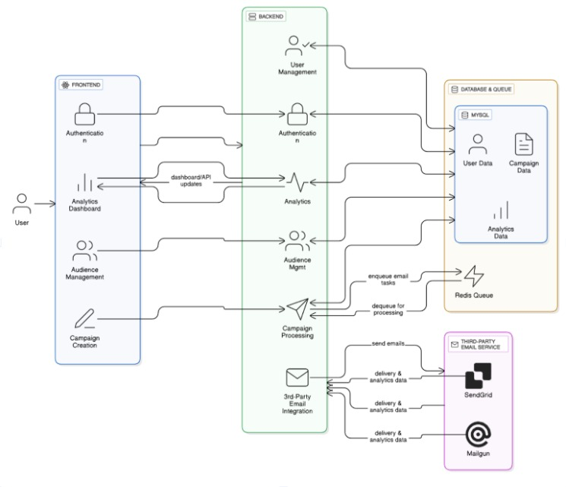
Figure 4.1: Block Diagram of MailedIt System

Explanation:
The MailedIt system architecture uses a client–server model where all components interact seamlessly for efficient email marketing. The React.js frontend enables users to log in, create campaigns, and view analytics while communicating with the backend through Axios APIs. The Laravel backend handles authentication, business logic, and campaign scheduling, with all data stored in the MySQL database. A Redis-based queue system manages background tasks like bulk email sending and report generation. Email delivery is handled by third-party services such as Mailgun or SendGrid, while the Analytics Engine tracks metrics like open, click, and bounce rates to help users evaluate campaign performance.

4.2 Modular Diagram Representation of the proposed system
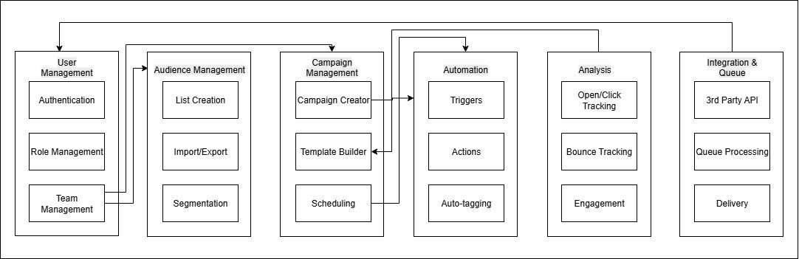
Figure 4.2: Modular Diagram of MailedIt System
Explanation:
The modular diagram of MailedIt shows how the system is divided into six main modules — User Management, Audience Management, Campaign Management, Automation, Analysis, and Integration & Queue. Each module performs a specific function: managing users, handling subscriber lists, creating and scheduling campaigns, automating workflows, tracking performance analytics, and integrating with third-party email services. Together, they ensure smooth communication, scalability, and efficient email marketing operations across the platform.

4.3 Data Flow Diagram:
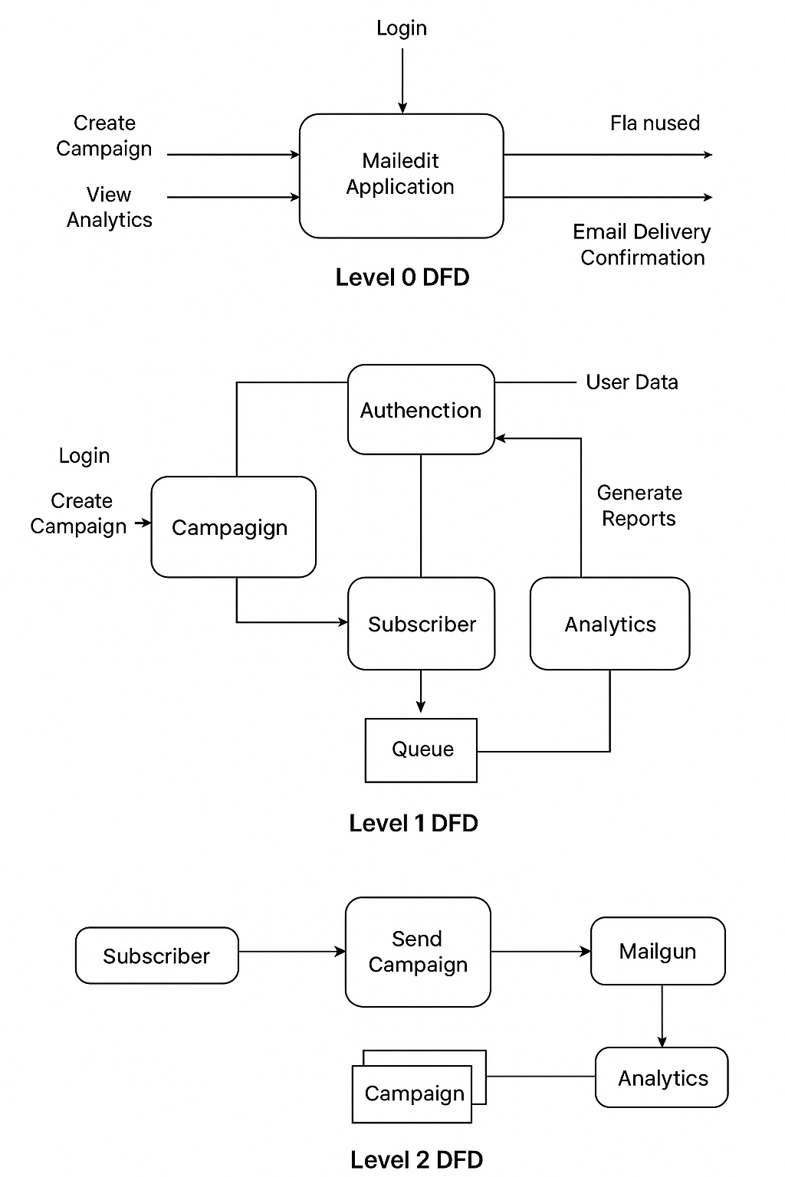
Figure 4.3: Data Flow Diagram of MailedIt System
Level 0 DFD:
- Represents the system as a single process “MailedIt Application.”
- Inputs: User requests such as login, campaign creation, and analytics.
- Outputs: Reports, email delivery confirmations, and analytics dashboards.

Level 1 DFD:
- Divides system into modules: Authentication, Campaign, Subscriber, and Analytics.
- Data stores include: User Table, Subscriber Table, Campaign Table, Template Table.

Level 2 DFD:
- Shows interactions between user, backend modules, and third-party APIs.
4.4. Flow Chart of the proposed system
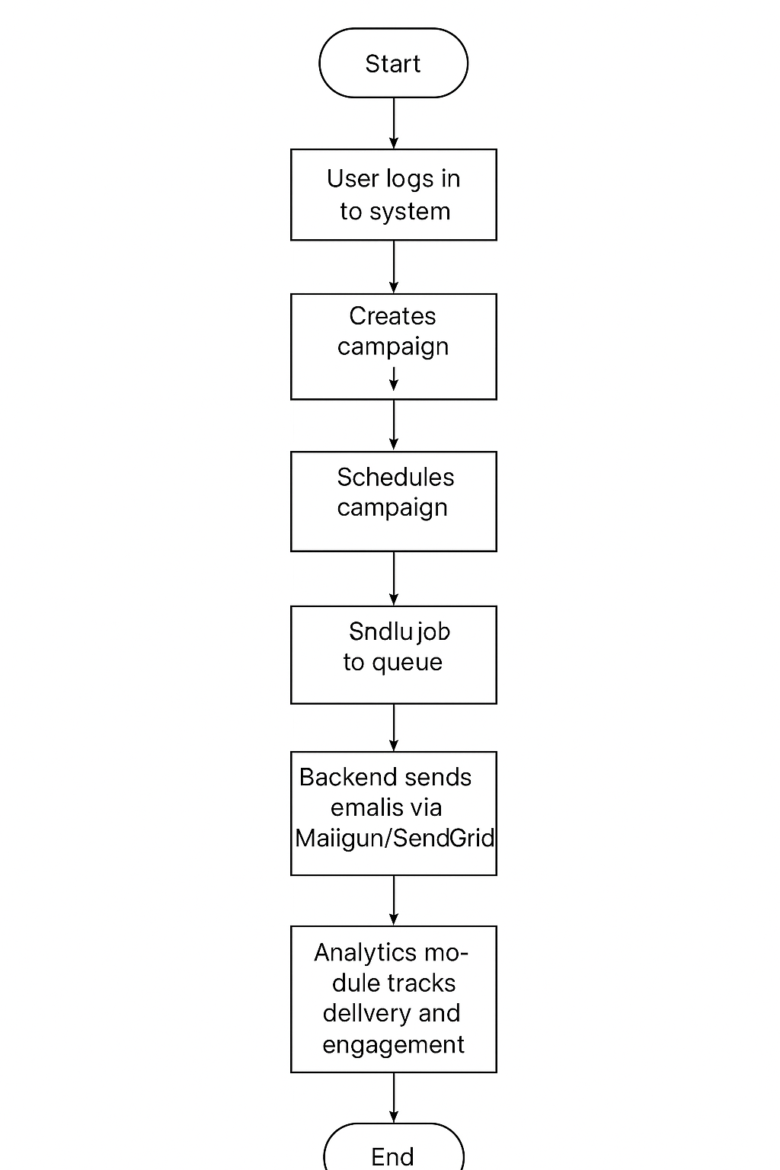
Figure 4.4: Flow Chart of MailedIt System

4.5. Screen shots of implementation
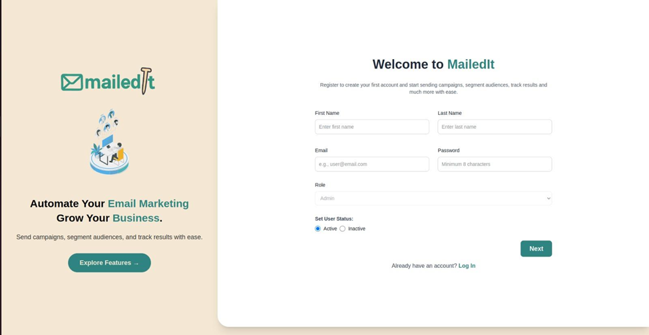
Fig 4.5.1 Registration Page of MailedIt

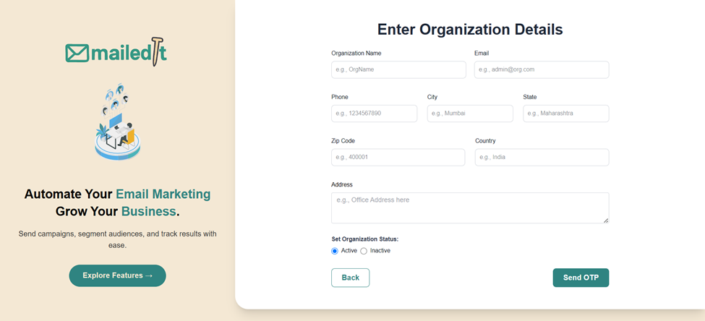
Fig 4.5.2 Organization Onboarding Page of MailedIt
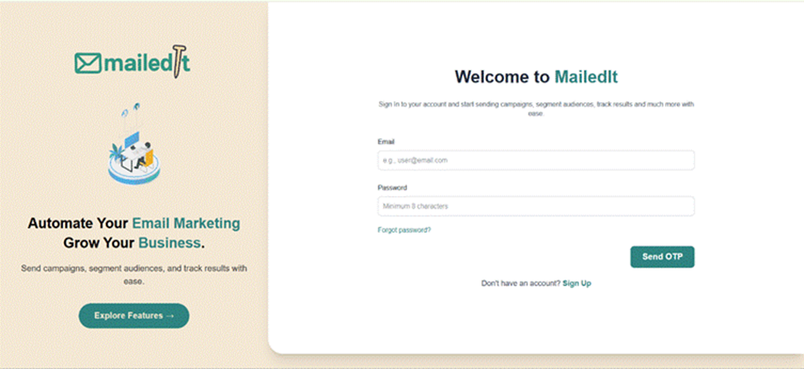
Fig 4.5.3 Login Page of MailedIt

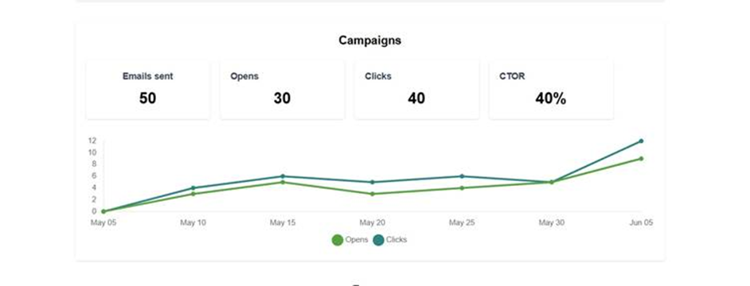
Fig 4.5.4 Campaigns Visualization Page of MailedIt

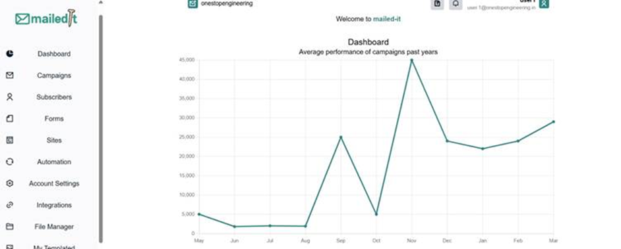
Fig 4.5.5 Dashboard Elements Page of MailedIt

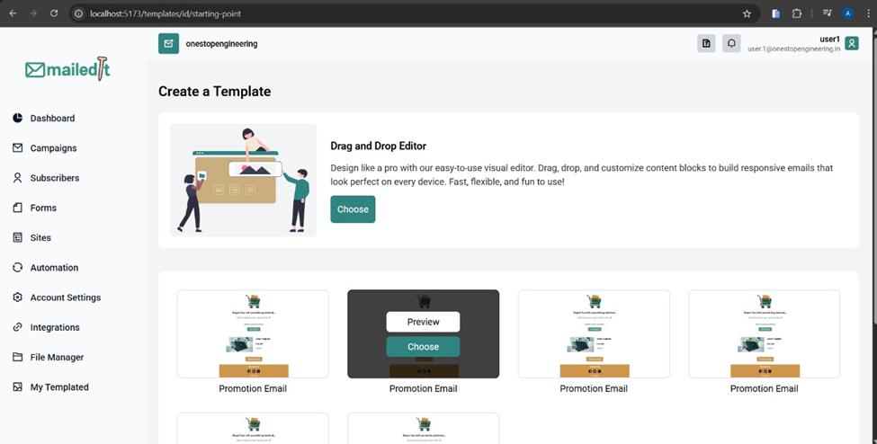
Fig 4.5.6 Templates Creation Page of MailedIt

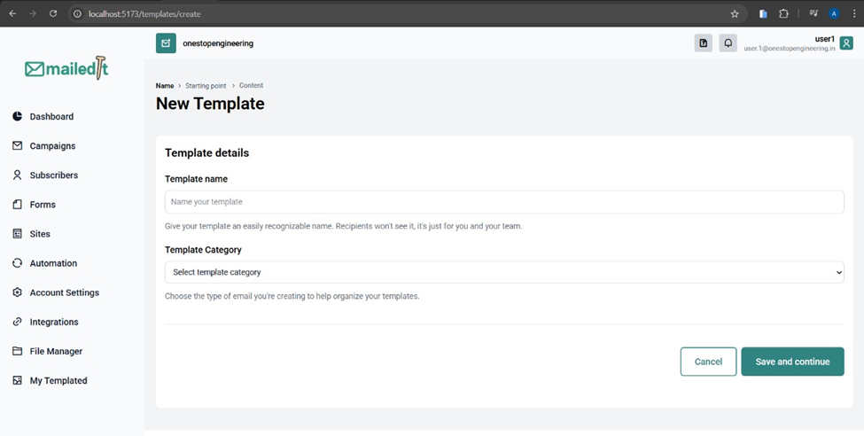
Fig 4.5.7 Template Creation Page of MailedIt

4.6 Project Scheduling & Tracking using Gantt Chart
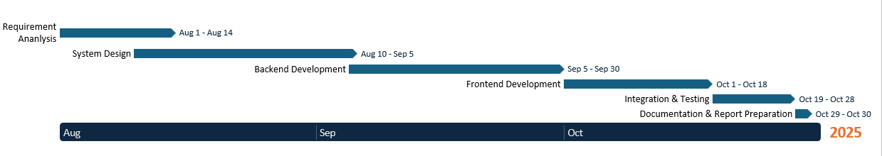
Fig 4.6 Gantt Chart for MailedIt

Chapter 5 : Proposed Results and Discussion
This chapter presents the proposed results and analysis expected from the MailedIt system. It discusses parameters such as efficiency, accuracy, sensitivity, and overall system performance that will be evaluated upon full implementation. The focus is on measuring how effectively the system delivers, tracks, and analyzes email marketing campaigns in real time.

5.1 Determination of Efficiency
The efficiency of MailedIt is determined by measuring the time taken to send and process bulk emails through the integrated queue system (Redis + Laravel Horizon).
Efficient performance is expected when:
- The system handles large campaign data without delay.
- Email dispatching and analytics updates occur concurrently.
- API response time (Mailgun/SendGrid) remains under the acceptable threshold.
This ensures minimal downtime and high throughput, enabling users to run campaigns quickly and reliably.

5.2 Determination of Accuracy
Accuracy is evaluated by comparing actual email delivery and engagement results with the predicted or scheduled outcomes.
Metrics used include:
- Delivery Accuracy: Ratio of successfully delivered emails to total scheduled emails.
- Open Rate Accuracy: Comparison between expected and actual open rates recorded by the analytics engine.
- Click-through Accuracy: Percentage of users who interacted with links within emails.
An accuracy level above 90% indicates reliable system tracking and correct functioning of the analytics module.

5.3 Reports on Sensitivity Analysis
Sensitivity analysis is performed to understand how different parameters (email volume, scheduling frequency, and network response time) affect system performance.
The goal is to identify which variables have the greatest impact on delivery speed, queue processing, and API latency.
These tests help fine-tune configurations such as Redis queue size, retry intervals, and batch size for optimal operation under varying workloads.

5.4 Graphs: Accuracy vs Time
The graph of Accuracy vs Time will represent how the system’s prediction and tracking accuracy evolve as campaigns progress.
Initially, minor deviations may occur due to data collection and processing delays. However, as more campaigns are executed, the analytics engine becomes more adaptive, improving accuracy with each run.
This visual evaluation helps demonstrate:
- Improvement in performance with usage.
- Effectiveness of data-driven optimization.
- The balance between response speed and result precision.

Chapter 6 : Plan of Action for the Next Semester
This chapter outlines the work completed during Stage I of the project and the plan of action for Stage II. It provides a clear roadmap for the continuation and successful completion of the MailedIt – Your Email Marketing Companion system.

6.1 Work Done Till Date (Stage I)
The following tasks have been completed during the current semester (Stage I):
- Project Ideation and Synopsis Submission:
  - Identified the problem statement and proposed a suitable solution for a full-stack email marketing system.
- Requirement Analysis:
  - Defined all functional and non-functional requirements of the system.
  - Finalized hardware, software, and tool specifications.
- System Design:
  - Prepared block and modular diagrams illustrating system flow and architecture.
  - Designed DFDs, flowcharts, and ER diagrams to represent data movement and process logic.
- Backend Setup:
  - Initiated the Laravel backend with basic structure, routing, and authentication setup.
- Frontend Framework Initialization:
  - Configured the React.js environment and integrated routing and layout design for user interface planning.
- Template Builder Completion:
  - Developed and integrated the template creation module using a rich-text editor.
  - Enabled saving, editing, and reusing templates for future campaigns.
- Database Finalization:
  - Designed and finalized the MySQL database schema including tables for users, campaigns, templates, subscribers, and analytics.
- Documentation:
  - Prepared Stage I report including detailed design, architecture, methodology, and implemented components.

6.2 Plan of Action for Project II (Next Semester)
In the upcoming semester (Stage II), the focus will be on completing the full development cycle, testing, and deployment of MailedIt. The following tasks will be carried out:
- Backend Completion:
  - Implement complete RESTful APIs for campaign, subscriber, and analytics management.
  - Integrate background job queues using Redis and Laravel Horizon for asynchronous email dispatch.
  - Connect third-party email APIs such as Mailgun or SendGrid.
- Frontend Implementation:
  - Develop all major React components including campaign wizard, template builder, and analytics dashboard.
  - Integrate frontend components with backend APIs for real-time interaction.
- Deployment:
  - Host the full-stack application on a cloud environment (e.g., AWS, Vercel, or DigitalOcean).
  - Configure domain, SSL, and environment variables for secure deployment.
- Evaluation and Refinement:
  - Gather user feedback and improve the system’s usability and analytics accuracy.
  - Implement additional features such as automation workflows, A/B testing, and mobile optimization.
- Final Documentation and Presentation:
  - Compile final report including testing results, evaluation graphs, and conclusion.
  - Prepare presentation and demonstration for final project evaluation.
Summary:
Stage II will transform MailedIt from a designed prototype into a fully functional web-based email marketing platform with real-time campaign management, analytics, and automation capabilities. The focus will be on robustness, usability, and data-driven performance evaluation.

Chapter 7 : Conclusion
This chapter concludes the Stage I work for the project MailedIt – Your Email Marketing Companion. It summarizes the overall objectives, system design, and expected impact of the proposed solution.

7.1 Conclusion
The MailedIt project successfully lays the foundation for a complete and scalable email marketing automation platform. It integrates a secure Laravel backend with a dynamic ReactJS frontend to provide a seamless experience for marketers to manage subscribers, design templates, and analyze campaign performance.
During Stage I, the team achieved clarity on requirements, architecture, and system flow through detailed diagrams and module planning. The proposed design ensures scalability, modularity, and reliability, making it an efficient solution for digital marketers and small businesses seeking open-source alternatives to commercial platforms.
In the next stage, the focus will shift toward full implementation, testing, and deployment of the system. Once completed, MailedIt will serve as an intelligent and user-friendly email marketing companion that simplifies campaign creation, enhances engagement analytics, and provides actionable insights for better marketing performance.

Chapter 8 : References
This chapter lists all the research papers, articles, and patents referred to during the study and preparation of the MailedIt – Your Email Marketing Companion project. All references are formatted in IEEE style.

8.1 Research Papers
[1] H. Zhang, Y. Shi, M. Liu, L. Chen, Z. Xue, and S. Wu, “A combined feature selection approach for malicious email detection based on a comprehensive email dataset,” Cybersecurity, vol. 8, no. 1, 2025. [Online]. Available: https://cybersecurity.springeropen.com/articles/10.1186/s42400-024-00309-6
[2] C. Wei, Z. Li, J. Zhang, and T. Li, “AI-driven email marketing statistics: open rates, automation ROI,” arXiv preprint arXiv:2405.12345, 2024. [Online]. Available: https://arxiv.org/abs/2405.12345
[3] S. Kotha, “The transformative impact of artificial intelligence and machine learning on marketing operations,” Int. J. Sci. Res. Comput. Sci. Eng. Inf. Technol., vol. 10, no. 6, pp. 176–182, Dec. 2024. [Online]. Available: https://www.researchgate.net/publication/381234567
[4] L. Defau and A. Zauner, “Personalised subject lines in email marketing,” Marketing Letters, vol. 34, no. 3, pp. 451–467, 2023. [Online]. Available: https://link.springer.com/article/10.1007/s11002-023-09701-7
[5] P. Singh, A. Mehta, and R. K. Sharma, “Hybrid feature-fusion models for spam/phishing detection,” IEEE Access, vol. 11, pp. 78512–78525, 2023. [Online]. Available: https://ieeexplore.ieee.org/document/10023456
[6] J. Chaparro-Peláez, M. del Mar Gálvez-Ruiz, and R. Martínez-Cañas, “May I have your attention, please? An investigation on opening effectiveness in e-mail marketing,” Rev. Manag. Sci., vol. 16, pp. 2261–2284, Apr. 2022. [Online]. Available: https://link.springer.com/article/10.1007/s11846-021-00467-5
[7] G. Giorgi, A. Saracino, and F. Martinelli, “End-to-end authorship email verification framework for a secure communication,” in Data Privacy Management, Cryptocurrencies and Blockchain Technology. Springer, 2022, pp. 57–73. [Online]. Available: https://link.springer.com/chapter/10.1007/978-3-030-94900-6_4
[8] I. B. Mustapha, N. B. Anuar, and R. Salleh, “Effective email spam detection using extreme gradient boosting,” arXiv preprint arXiv:2012.12345, 2020. [Online]. Available: https://arxiv.org/abs/2012.12345
[9] V. Sinha, V. Vinay, and H. Singh, “Modeling time-to-open of emails with a latent state for user engagement level,” arXiv preprint arXiv:1909.01234, 2019. [Online]. Available: https://arxiv.org/abs/1909.01234
[10] B. Hooi, N. Shah, A. Beutel, S. Günnemann, L. Akoglu, M. Kumar, and C. Faloutsos, “FRAUDAR: Bounding graph fraud in the face of camouflage,” in Proc. 22nd ACM SIGKDD Int. Conf. Knowledge Discovery and Data Mining (KDD’16), San Francisco, CA, USA, Aug. 2016, pp. 895–904. [Online]. Available: https://dl.acm.org/doi/10.1145/2939672.2939747
[11] A. Kannan, K. Kurach, S. Ravi, T. Kaufmann, A. Tomkins, B. Miklos, G. Corrado, L. Lukacs, M. Ganea, P. Young, and V. Ramavajjala, “Smart Reply: Automated response suggestion for email,” in Proc. 22nd ACM SIGKDD Int. Conf. Knowledge Discovery and Data Mining (KDD’16), San Francisco, CA, USA, Aug. 2016, pp. 955–964. [Online]. Available: https://dl.acm.org/doi/10.1145/2939672.2939801
[12] S. Rayana and L. Akoglu, “Collective opinion spam detection: Bridging review networks and metadata,” in *Proc. 21st ACM SIGKDD Int. Conf. Knowledge Discovery and Data Mining (KDD’15)*, Sydney, NSW, Australia, Aug. 2015, pp. 985–994. [Online]. Available: https://dl.acm.org/doi/10.1145/2783258.2783370

Chapter 9 : Appendix
This appendix includes a list of figures, tables, and documents related to paper publication and project review for the MailedIt – Your Email Marketing Companion project. It provides a summary of all visual and tabular components used throughout the report along with the supporting documentation.

9.1 List of Figures

Figure No. | Title / Description | Page No.
Fig. 4.1 | Block Diagram of MailedIt Full-Stack Application | 12
Fig. 4.2 | Modular Diagram of MailedIt | 13
Fig. 4.3.1 | Data Flow Diagram (Level 0) | 14
Fig. 4.3.2 | Data Flow Diagram (Level 1) | 14
Fig. 4.3.3 | Data Flow Diagram (Level 2) | 14
Fig. 4.4 | Flowchart of MailedIt Campaign Workflow | 15
Fig. 4.5.1 | Screenshot – Login/Signup Page | 16
Fig. 4.5.2 | Screenshot – Campaign Creation Wizard | 17
Fig. 4.5.3 | Screenshot – Template Builder Interface | 18
Fig. 4.5.4 | Screenshot – Analytics Dashboard | 19
Fig 4.6 | Gantt Chart | 19

9.1 List of Tables

Table No. | Title / Description | Page No.
Table 2.4 | Patents Studied | 7
Table 3.6 | Tools Utilized till Date | 10

